How to set the Dual band Wireless Router to assign a static IP address to a specified device in LAN
Product line: wireless question category: function config

Q：Why we need set the static IP binding?
A：By default the DHCP Server of the router will assign an available IP to the devices in LAN when the device is turned on, which means the IP for the device is dynamic.If we want to control the devices in LAN by IP, we need to set the static IP binding.

The Steps are as below:
- Login to the management page of the router.
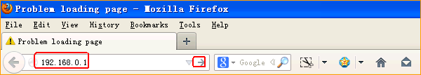
2.Input login username, password: admin, admin(default), to login, then click Advanced.
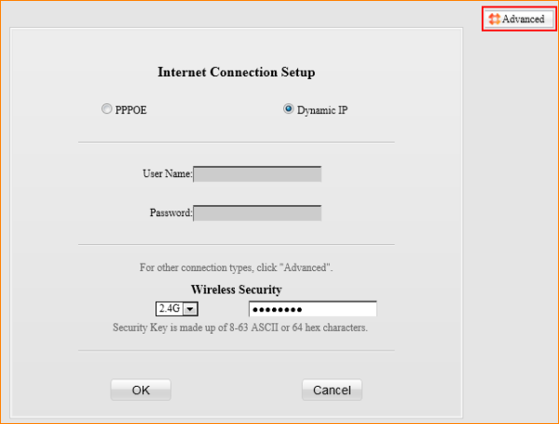

- Click on Network then go to DHCP, and click on Static Assignment and add specified IP for specified device.
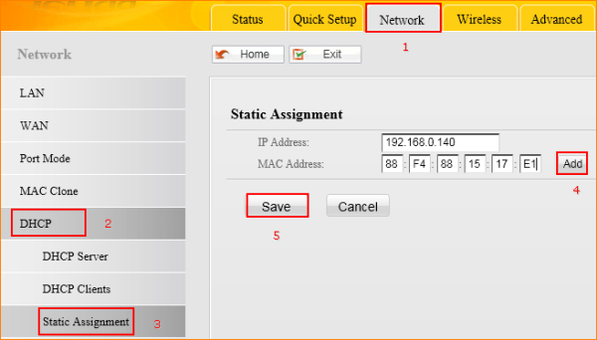

As the picture above, after settings, the device with MAC Address 88:F4:88:15:17:E1 will get the IP address of 192.168.0.140 all the time.

